**Module 2: Git Assignment – 2**

1. Created working directory with feature1.txt and feature2.txt.

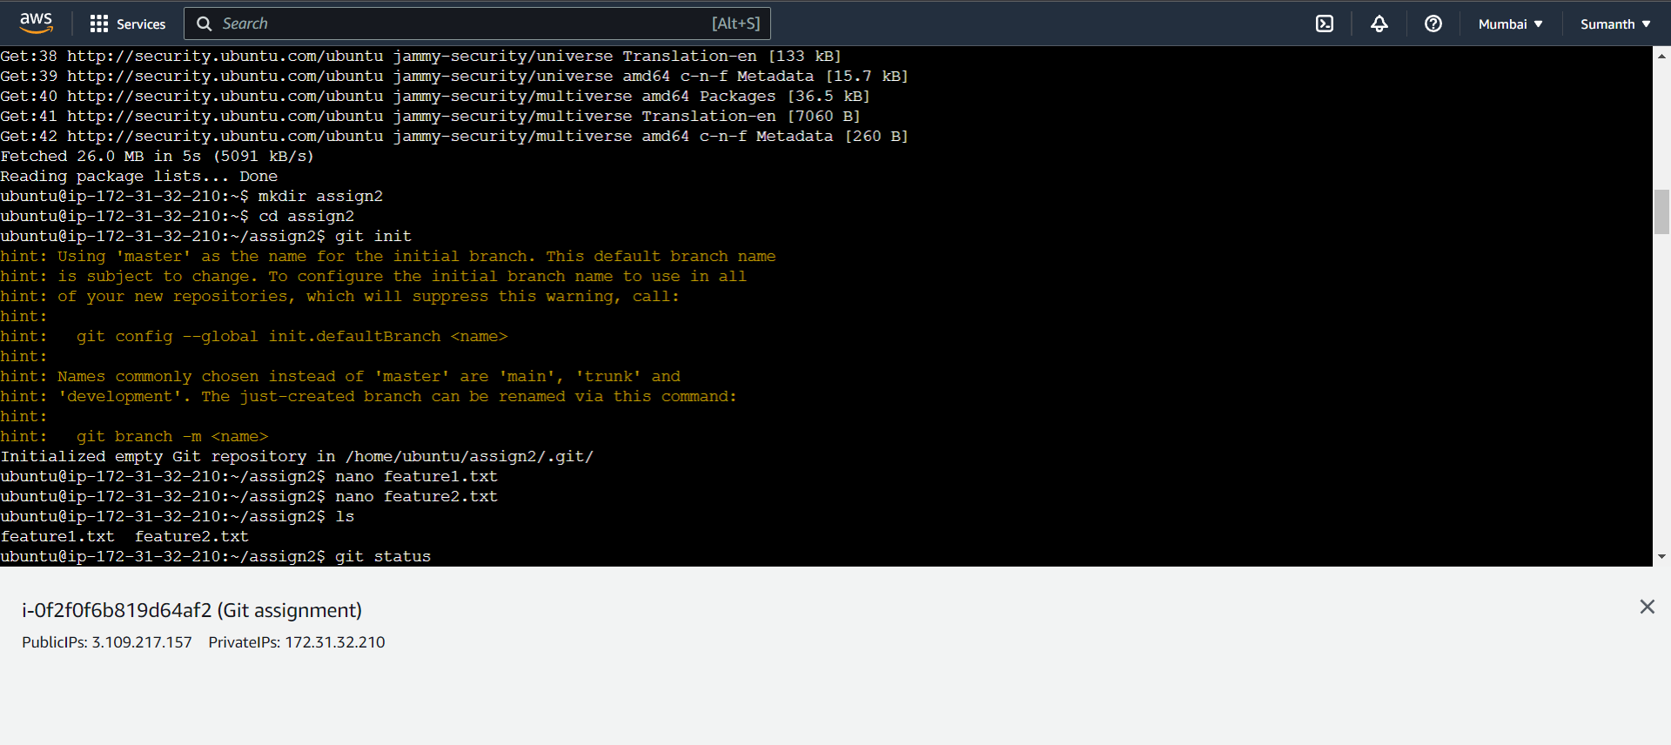

1. As instructed, created 3 branches develop, feature1 and feature2

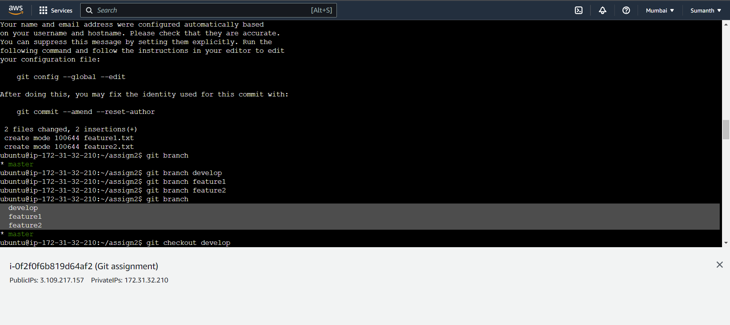

1. Then created develop.txt in develop branch and the stashed the file

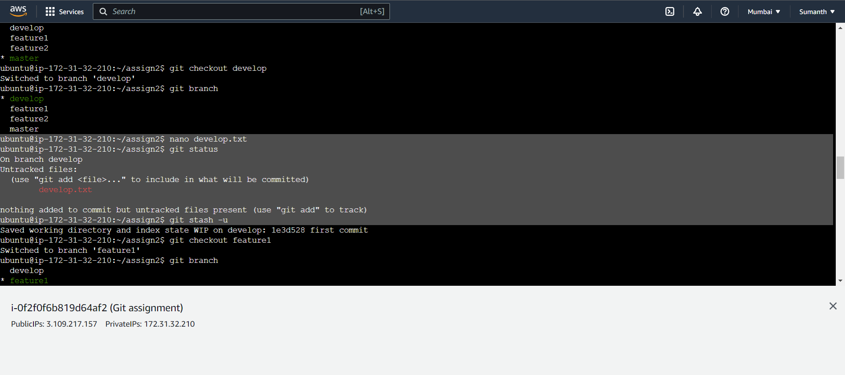

1. Created new.txt file in feature1 branch. Staged and committed that file

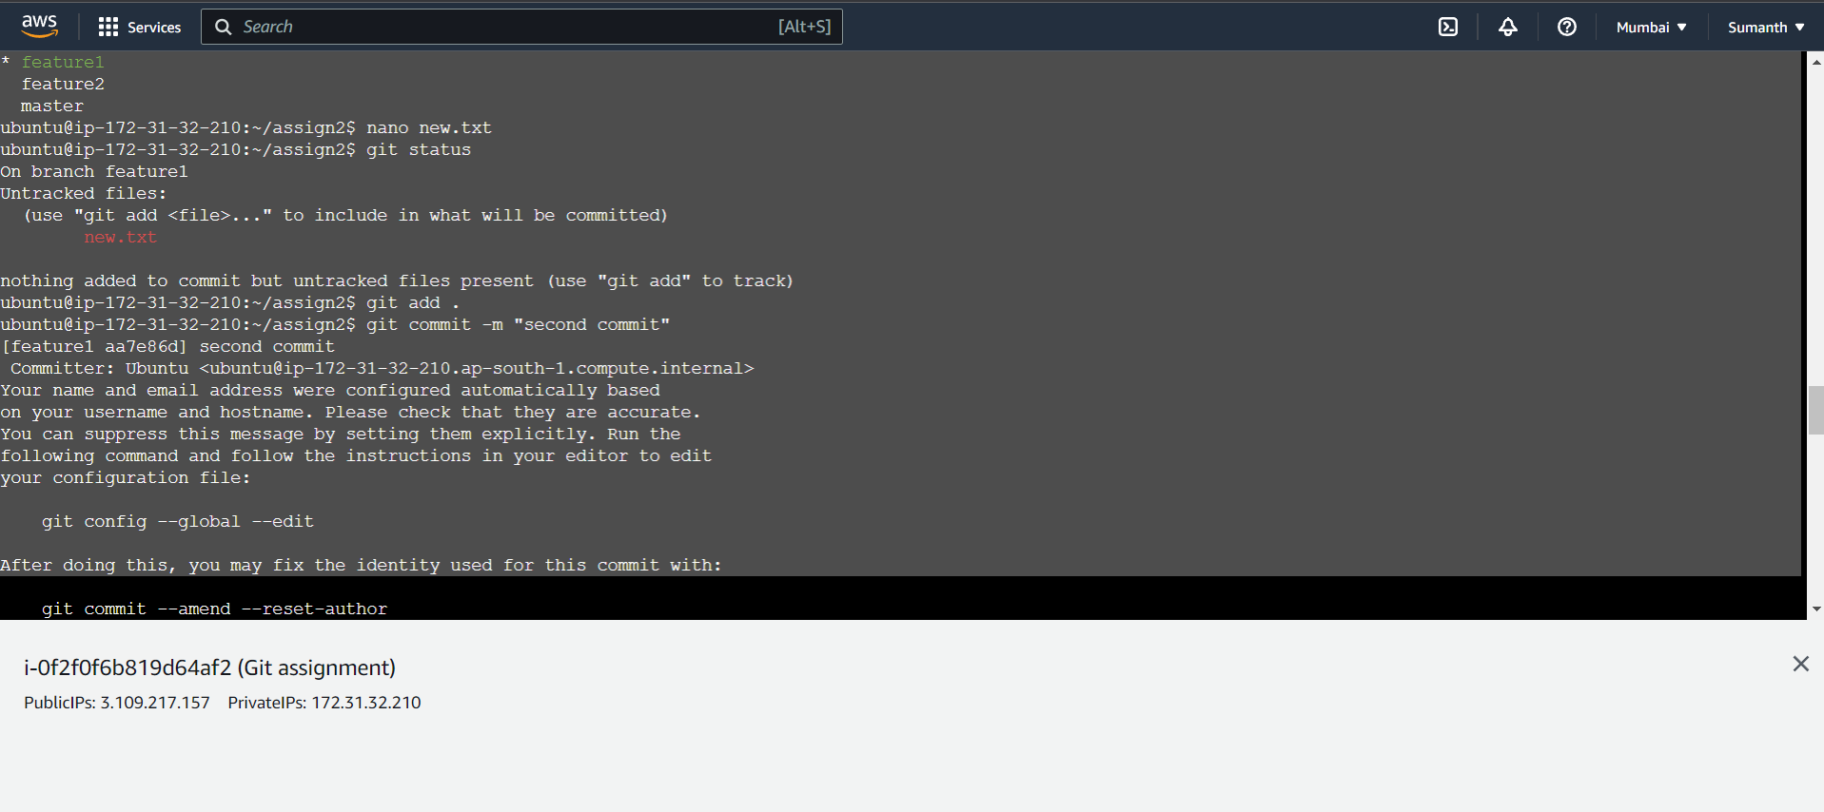

1. Unstash the develop file and committed that file

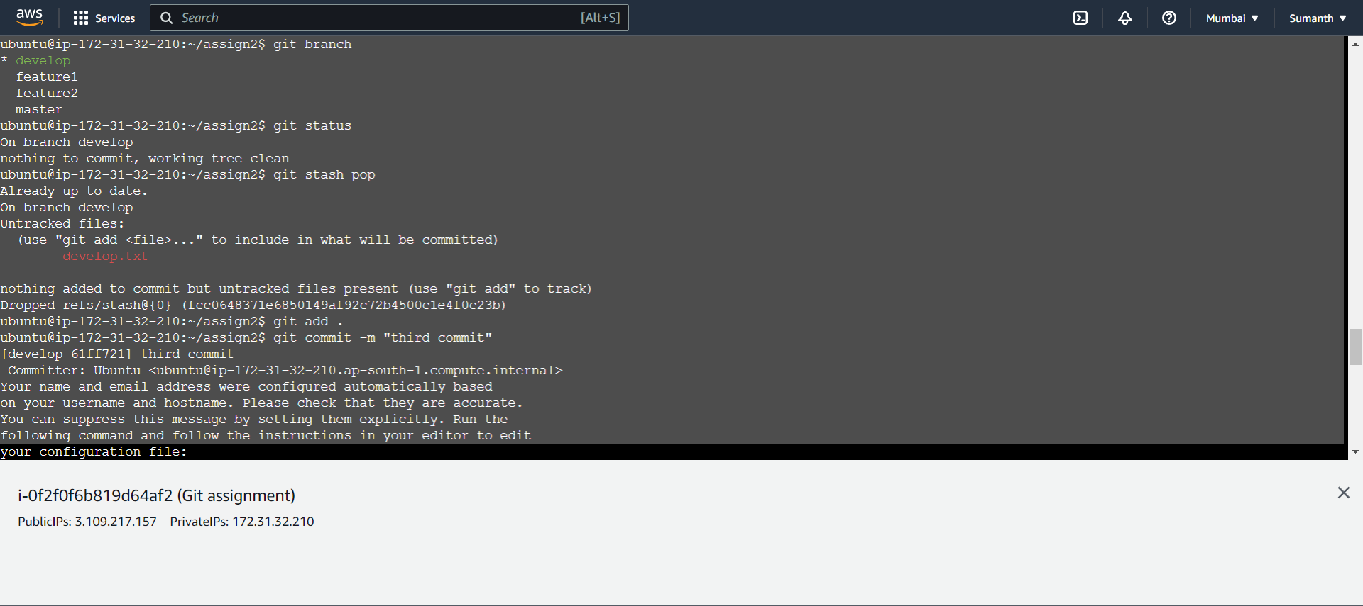

1. The Git commands used to do the above steps-

1 sudo apt-get update

2 mkdir assign2

3 cd assign2

4 git init

5 nano feature1.txt

6 nano feature2.txt

7 ls

8 git status

9 git add .

10 git status

11 git commit -m "first commit"

12 git branch

13 git branch develop

14 git branch feature1

15 git branch feature2

16 git branch

17 git checkout develop

18 git branch

19 nano develop.txt

20 git status

21 git stash -u

22 git checkout feature1

23 git branch

24 nano new.txt

25 git status

26 git add .

27 git commit -m "second commit"

28 git checkout develop

29 git branch

30 git status

31 git stash pop

32 git add .

33 git commit -m "third commit"

34 git status